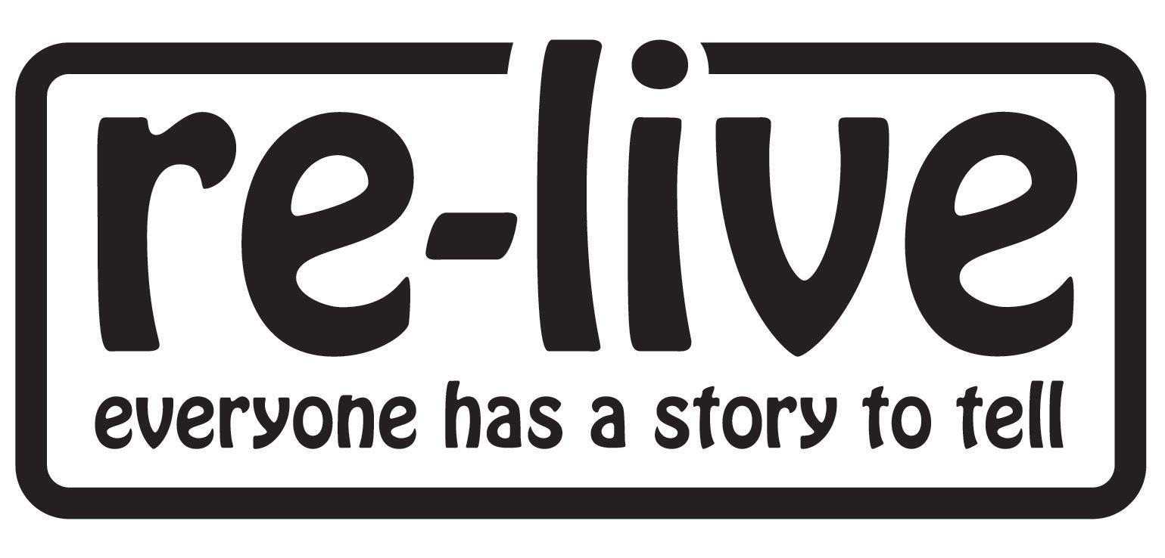

**Memoria**

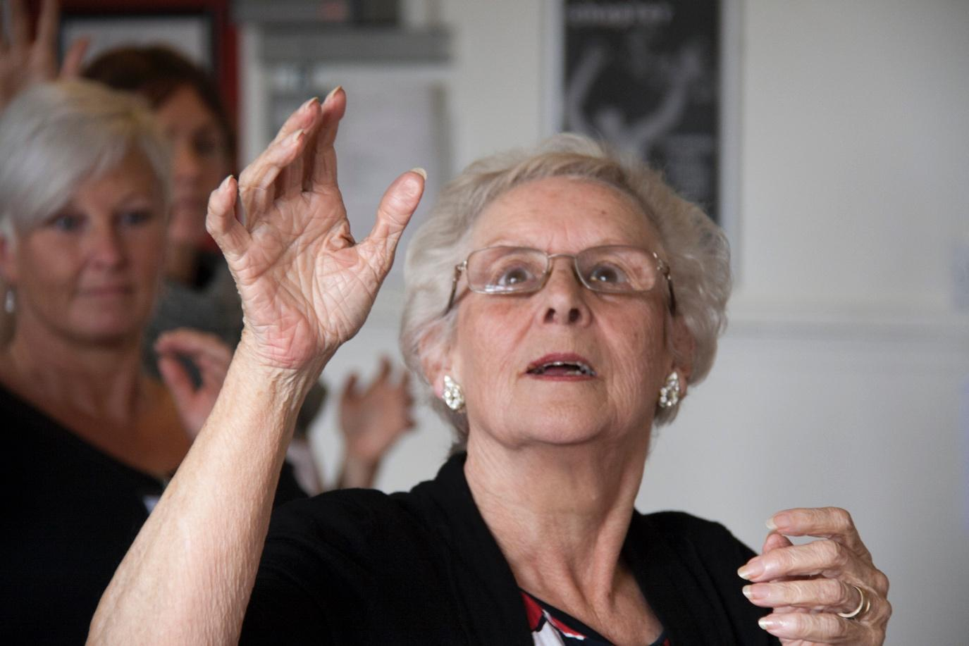

Jeannette Carter, **Memoria** rehearsals (2014)

“This project has transformed our relationship with dementia, the fear, the terror, the loneliness. We started to learn that we don’t have to be afraid or proud or silent. We need this opportunity to express what we’re going through” **Memoria participant**

In 2014, Re-Live produced **Memoria** a theatre production featuring people living with dementia, family members and a Care Home Manager, sharing their experiences of dementia on stage.

**Memoria** was performed to sold out audiences at Chapter, Cardiff and live streamed to over 4,000 people in 12 countries.

**Memoria** won Age Cymru’s Community Award (2015).

“I feel less afraid of dementia because there they were, on stage, telling their stories with humour, strength and determination” **Audience Member**

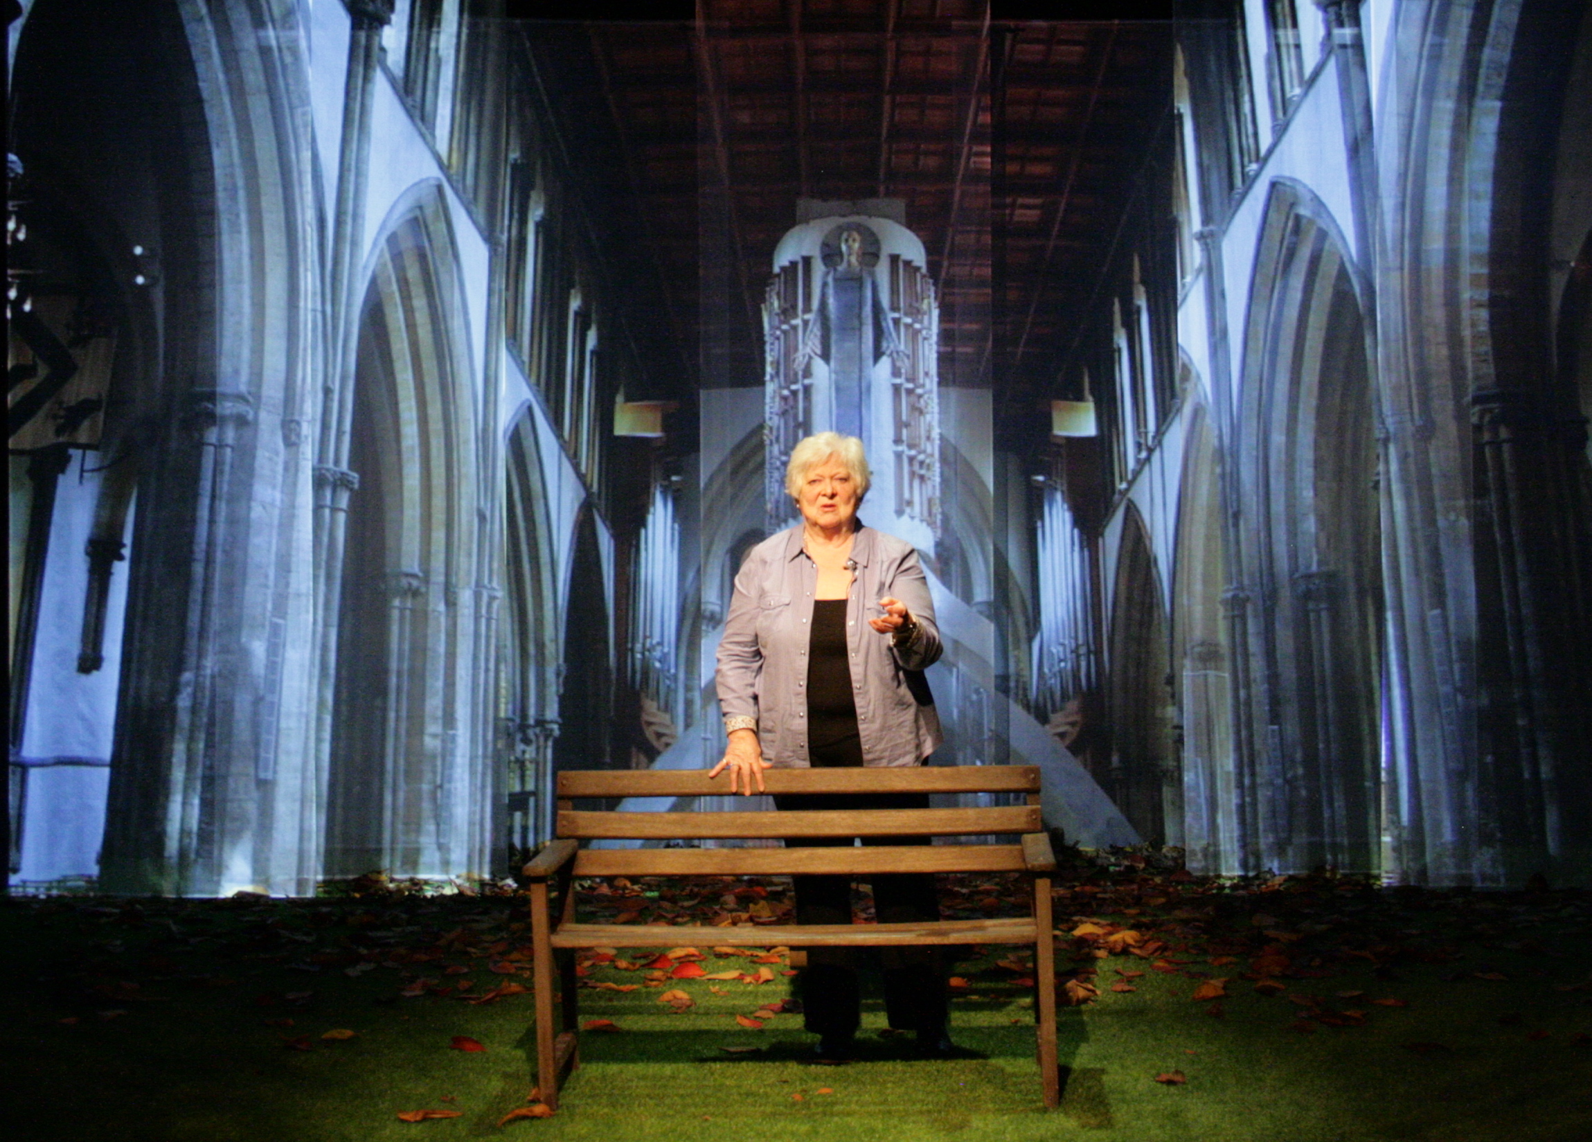

Jill Grey, **Memoria** performance (2014)

The **Memoria** group have performed a 40-minute excerpt of the show in conferences and community settings across Wales, including the National Social Care Conference (2018), to raise public awareness, encourage policy dialogue and advocate the benefits of Arts in Health practice.

Since the show, the **Memoria** group continues to meet monthly at Chapter, devising new Life Story Theatre work and welcoming new members. The group provides a creative space for participants to reflect and share experiences of dementia, reducing fear, loneliness and isolation. It improves overall wellbeing and helps maintain the bonds of socialisation and connectedness that all too often disappear for families post-diagnosis.

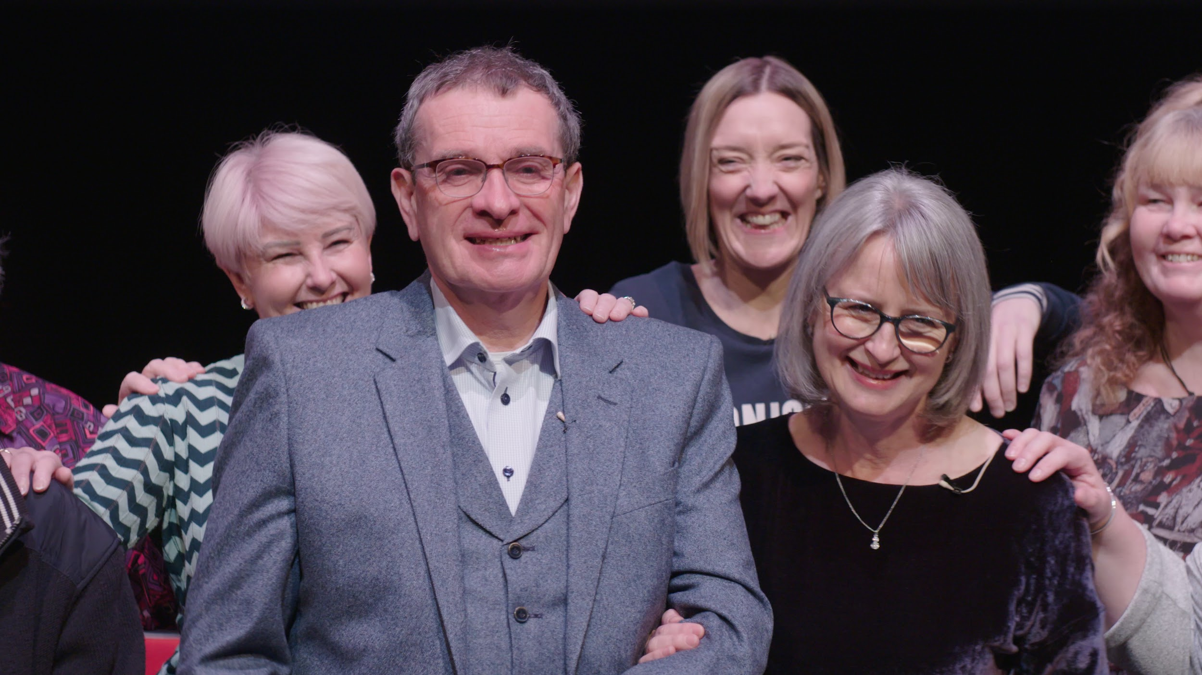

Nick and Karen, **Memoria NOW** performance (2019)

“I can’t tell you how much this has meant to Nick and me. I felt that the experience of “telling our story” was not only liberating but also empowering. Nick has talked about the performance a lot this morning and has said that he was able to follow everything that happened and felt wholly engaged.  He said he felt that it was definitely good for his brain and his sense of well-being.” **Karen and Nick Gibbs, Memoria participants**

A new work from the group, **Memoria NOW** was performed at The Atrium Theatre University of South Wales (USW) on April 4th 2019. The sharing was filmed by adocumentary team from The Memory and Aging Center (MAC) at The University of California, San Francisco for a documentary on global perspectives on memory and aging. The film will be launched in Autumn 2020.

**Partners:** The Arts Council of Wales, DEEP, Chapter, Cardiff City Council.

**Cost:** Funded by The Arts Council of Wales, DEEP, Dementia Friendly Communities Grant (Cardiff and Vale), Re-Live: £64,000 (2014 -)

**Evaluation:** Participant feedback forms and questionnaires, and through oral evaluation where reading and writing was not appropriate.

Re-Live’s future ambition is to establish **Memoria** groups across Wales to:

* share the transformational impact of creativity in dementia care
* raise awareness of the current issues facing people living with dementia in Wales to influence policy and practice
* share best practice in the field of Arts in Health and Wellbeing work

You can watch a performance of **Memoria** [here](http://www.re-live.org.uk/memoria)

You can watch a post-performance Q&A [here](http://www.re-live.org.uk/memoria)

**Publications:**

Clark Baim - **Theatre, Therapy and Personal Narrative:** Developing a framework for safe, ethical, flexible and intentional practice in the theatre of personal stories (p.247-255), University of Exeter, 2018

*“****Memoria***demonstrated how theatre can address highly personal themes with participants - even profoundly vulnerable themes — and maintain high levels of safety, ethical rigor and aesthetic form”

You can read Clark Baim’s case study on **Memoria** in full [here](https://ore.exeter.ac.uk/repository/bitstream/handle/10871/33997/BaimC.pdf?sequence=1&isAllowed=y)

For more information about Re-Live, please visit: [www.re-live.org.uk](http://www.re-live.org.uk)